Ansible Assignment #1 Creation Steps:

1. Creation of 3 Virtual Machines on VMWare Hypervisor:

Ubuntu 64Bit- Rahul-virtual-machine

Ubuntu 64Bit Second- Virtual2

Ubuntu 64Bit Third- Virtual3

1. To install open SSH Servers for all 3 machines;

sudo apt install openssh-server

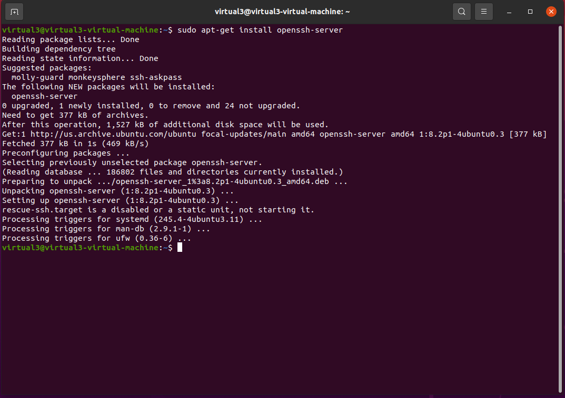

1. Install Ansible on Control Node (Virtual1)
   1. sudo apt update
   2. sudo apt install software-properties-common
   3. sudo add-apt-repository --yes --update ppa:ansible/ansible
   4. sudo apt install ansible

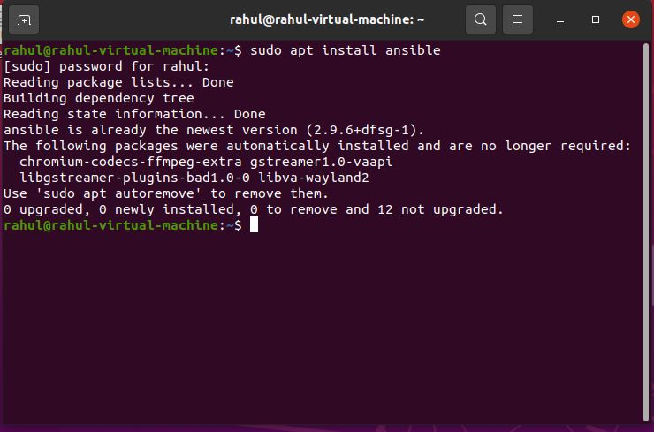

1. Add another 2 virtual Machines as host in the inventory of Ansible Control Node.

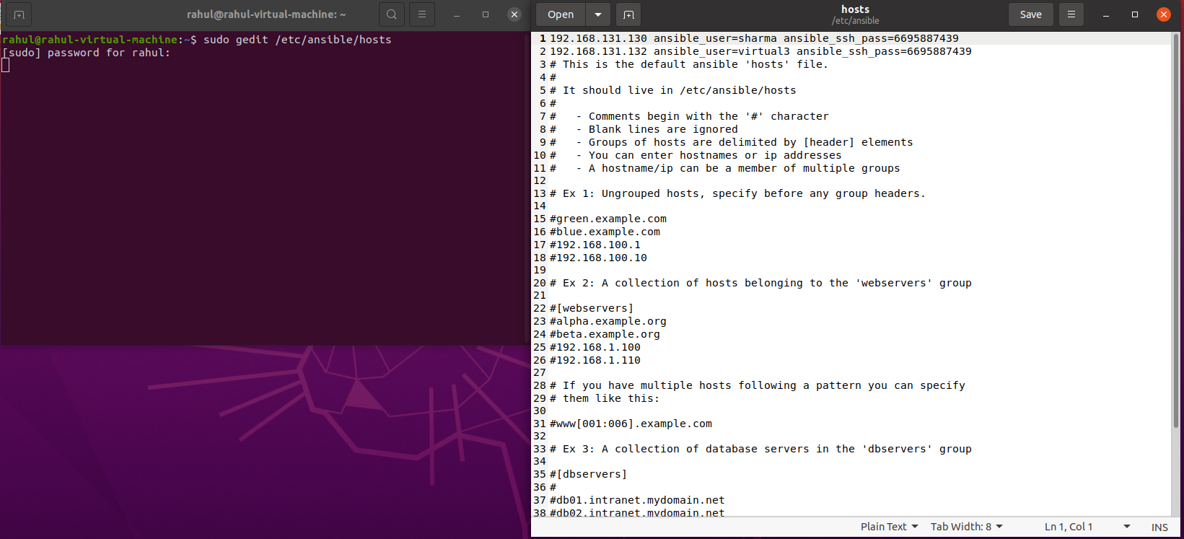

Machine IPs mentioned in inventory act as a host for the control node

1. To check if the connection has been established successfully between Host(s) and Control Node.
   1. To check for the connection between control node and host file
   2. ansible all -m ping

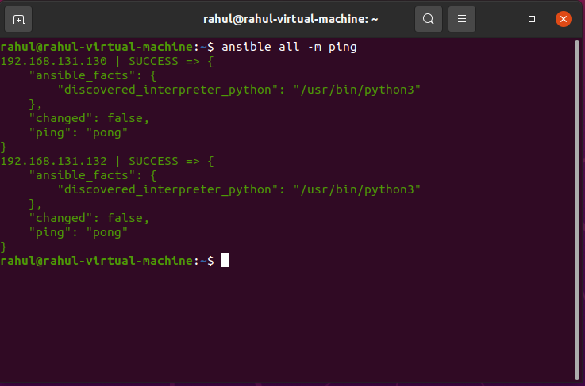

1. Install Apache WebServer on the host using the control Node.

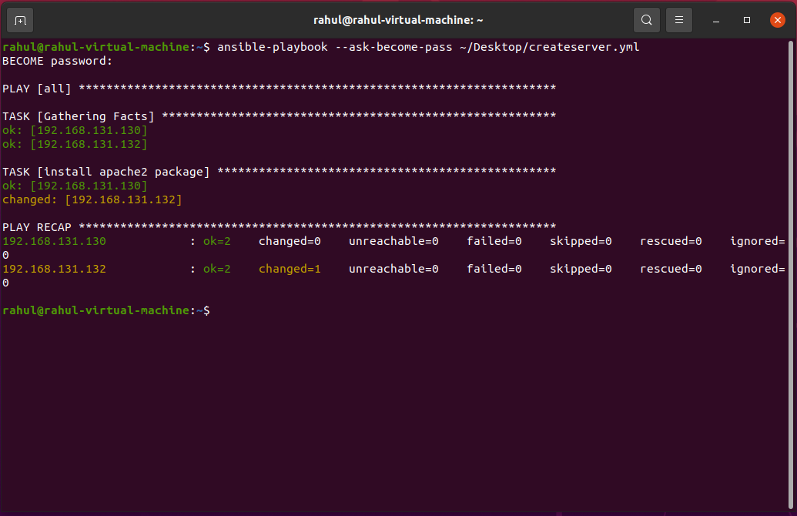

1. Send the HTML File to the Apache Servers of the host (In the root directory).

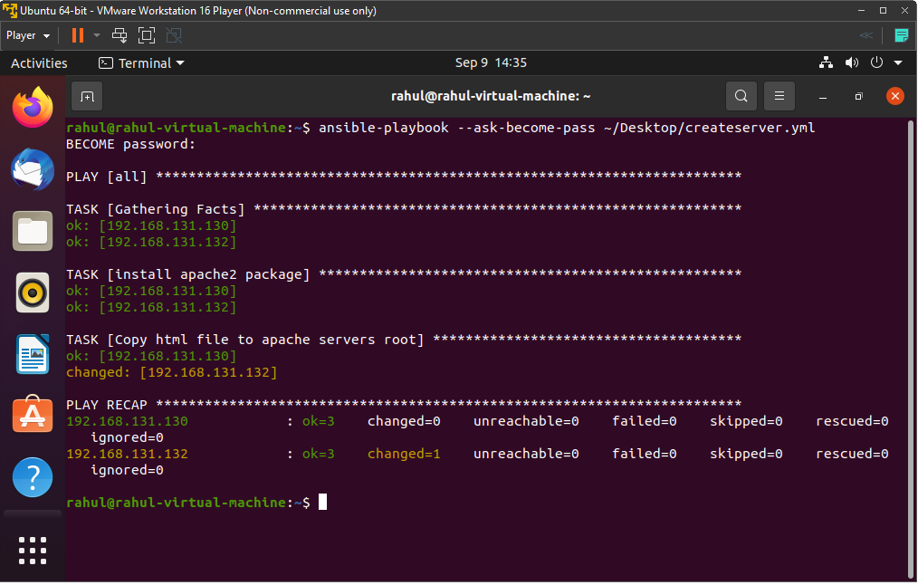

1. Start the services on the server.
   1. Ping received on the first Virtual Machine with IP Address: 192.168.131.130:8080



* 1. Ping received on the Second Virtual Machine with IP Address: 192.168.131.132:8080



1. Checking if the server has successfully started and is running.

